I worked for the U.S. government in Afghanistan. Am I eligible for an SIV?
What are the requirements to apply for SIV? If you have not applied previously, you must meet ALL of the following requirements to qualify for this SIV.
- You must be a citizen of Afghanistan; and
- You were employed in Afghanistan for at least one year;
  - By the U.S. government; or;
  - By a contractor with a contract for funding from the U.S. government; or;
  - With ISAF.
- You must have provided faithful and valuable service; and
- You face an ongoing serious threat because of your work.

How can I tell if I was employed by the U.S. government, by a contractor with a contract for funding from the U.S. government, or by ISAF? If you were a U.S. government or ISAF employee, you would have been paid directly by the U.S. government or ISAF. If you were employed by a company or organization, you would have to learn if the company or organization was working on a U.S. government “contract.”

What is a U.S. government “contract”? A “contract” is one way that the U.S. government agreed with and paid companies to do work in Afghanistan. However, the U.S. government did not pay all companies and organizations in Afghanistan through a “contract.” Some companies or organizations were paid in different ways through “grants,” “awards,” or “cooperative agreements.” See IRAP’s guide about finding information about a U.S. government contract here.

Does employment under a “grants,” “award,” or “cooperative agreement” qualify for an SIV?
The U.S. government has decided that only employees of companies or organizations that had “contracts” qualify for SIVs. Employees of companies or organizations that only received U.S. government funding through “grants,” “awards,” or “cooperative agreements” do not qualify for SIVs under this decision. If a company had contracts and other funding, the applicants who worked under U.S. government contracts can qualify for an SIV.

Has employment for the government of Afghanistan or the United Nations qualified for an SIV? According to the U.S. government, employment for the government of Afghanistan or an international organization like the United Nations does not qualify for an SIV.

Has employment for companies that had a contract with ISAF qualified for an SIV?
Employment for companies or organizations that have only had contracts or other funding with ISAF has also not qualified for an SIV. Companies must have had a U.S. government contract or subcontract.

Can I Apply for SIV for my Spouse or Child? Applicants who qualify for SIVs through any of these programs can also apply for visas for their spouse and unmarried children under 21. More information for SIV recipients who traveled without their spouse or children is here.

How can I Apply for SIV?

Step one: Chief of Mission (COM) approval If you are an Afghan SIV applicant you need to obtain Chief of Mission (COM) approval. More information on the COM process is located on the U.S. Department of State website here. At this step, you must submit information and documents to the COM over email. These documents include:
- Verification of your employment, also called a human resources letter.
  - IRAP’s guide on what this letter should include is here.
  - If you need help contacting your employer, IRAP’s guide is here.
- A recommendation letter from your supervisor.
  - IRAP’s guide on what this letter should include is here.
  - If you need help contacting your supervisor, IRAP’s guide is here.
- Proof that you worked for a company that worked with U.S. government funding.
  - IRAP’s guide to find contract information is here.
If you already started your COM application, but you do not have an answer on your application, IRAP’s guide on how to submit new documents for your COM application is here.
If you face long delays, IRAP’s guide on delayed U.S. immigration applications is here.
If your COM application is denied, IRAP’s guide on COM appeals is here.

Step two: USCIS petition After you receive COM approval, you must next submit a petition to the USCIS Nebraska Service Center. IRAP’s guide on submitting the I-360 is here.

Step three: Complete the visa application After you receive I-360 approval, you must complete the DS-260 and visa application process. IRAP’s guide on submitting the DS-260 visa application is here.

Can I still begin the SIV application process even though the U.S. Embassy in Afghanistan is currently closed? Yes. Steps one (COM approval), two (USCIS petition), and three (visa application) can all take place over the internet. Step four, the visa interview, must happen in-person at a U.S. embassy or consulate that has immigrant visa processing. Read IRAP’s guide on transferring a case here.

How can I find a former employer or supervisor for my SIV application? Where to search for your supervisor:
- Reach out to any of your supervisors whose names you know. The more people you contact, the more likely you are to get a positive response.
- Reach out in as many ways as possible.
- Some supervisors have common names. For example, a common first and last name in the U.S. is Mike Johnson. Many people would have this name. You might find a profile on social media with the same name. You can include a sentence saying, “I am hoping that you are the Mike Johnson who used to supervise me.”
- If the supervisor has a common name, it can also be helpful to look at pictures of your supervisor, which can help to identify the supervisor on LinkedIn.
These are websites that some individuals have found helpful in searching for their supervisors:
- LinkedIn.com Many supervisors are on LinkedIn. Search in the top search bar for your supervisor’s name. Then, on the left side of the screen, you can filter results. Filter using the ‘current employer’ or ‘former employer’ filter.
- Facebook.com You can reach out and communicate with potential supervisors and employers on Facebook. Search the name and filter for the individual’s employment. This can be useful, especially with less common names.

How to Email Your Former Supervisor or Employer
- If your supervisor has a military or academic title, address them by the title in your initial outreach for assistance. Otherwise, use “Ms.” or “Mr.”
- Give your name. If you had an English nickname, tell your supervisor or employer your nickname. They might remember your nickname more than your legal name.
- Give the dates and location that you worked with the supervisor or employer.
- Include a picture of you. If you have one, include a photo of you with the supervisor or other U.S. military or government employee.
- Explain that you are applying to move to the U.S. through the Special Immigrant Visa program. Explain the danger that you have faced because of your work.
- Explain that you need a letter of recommendation or HR letter for your application.
- If you have an old letter from them, you should attach that letter to your email.
- Send this information from the U.S. State Department about the requirements for a letter of recommendation or HR letter.
- Thank them for considering your request. Be respectful, polite, and patient. It is normal for supervisors to be cautious.

How can I get a letter from MEP?
If you worked for MEP, email LNL-OPSCELL@missionessential.com with the following information:
- Your name:
- Your tazkera number:
- Your Employee ID Number: AFGXXX
If you have an old HR letter, you should attach that letter to your email. You should also take a picture of yourself holding your tazkera to verify your identity. Attach that picture also to your email.

What do my recommendation and human resources letters need to include for my SIV application?

Background on applying for a Special Immigrant Visa:
- The current requirements for an SIV are on the Department of State’s SIV website here.
- You must include all the documents in your application to the Chief of Mission (COM).
- If you already submitted your COM application and are waiting for a decision, you can email new documents to AfghanSIVApplication@state.gov to add to your pending COM application. Look here for information about what you can do while your COM application is pending.
For people who worked for contractors for the Department of Defense, you can verify employment by getting the HR letter from your employer and a letter of recommendation from your supervisor.
Many people do not have all of these documents. In August 2021, the US government announced a process that applicants who worked for a Department of Defense can also use to show that they have eligible work. This process is called Project Rabbit. More information about Project Rabbit is below. If you worked for a company that had Department of Defense contracts, you should read the section on Project Rabbit below.

Employment Requirements: COM must verify your employment by or on behalf of the U.S government, ISAF, or a successor mission. You must show that you worked for at least one year. You must obtain the following letters from each U.S. company or organization you worked for:
- Letter of employment verification from the Human Resources department; and
- Letter of recommendation from your direct supervisor, who must be a U.S. citizen. If they are not a U.S. citizen, a U.S. citizen who is responsible for the contract must co-sign the letter.
Look here for IRAP’s guide on how to find your supervisor or employer. These people must have worked with you during your employment. IRAP’s guide on how to obtain proof that your work qualifies for the SIV program is here.
COM will need to verify your employment by or on behalf of the U.S government, or by ISAF or a successor mission. You must show that you worked for at least one year.
You may qualify for an SIV if:
- You worked directly with ISAF or a successor mission;
- You worked directly for the U.S. government; or
- Your company had a contract or subcontract with the United States government.
If you worked directly for the U.S. government, ISAF, or ISAF’s successor mission, submit your employment verification letter. This is a letter from your company’s human resources department. This is called the HR letter. It should be on the agency letterhead and should prove that your work qualifies. More information on what your employment letters should include is available below.

Letter of Employment Verification from Human Resources (HR letter) Make sure your HR letter has the following information:
- Applicant’s full name
- Applicant’s date of birth
- Contract information for all contracts and/or subcontracts:
  - Project name
  - Contract number
  - Duration of contract
  - Name of contractor company
  - Contracting U.S. government entity
  - If your employer was a subcontractor, include the information above about both the prime contract and subcontract
  - If available, include a copy of the contract or subcontract
- Applicant’s job title
- Applicant’s job location
- Start date of employment (date, month, year)
- End date of employment (date, month, year)
- Reason for separation from the job (if no longer employed)
- HR Representative Information:
  - Name of HR representative completing the HR letter
  - Their original signature
  - Their email address
  - Their phone number
  - The date the letter was signed
- If your employer does not have an HR unit, the letter writer should explain that.
- Only for ISAF employees: A description of the applicant’s work that required the applicant to either:
  - Work as an interpreter or translator for U.S. military personnel while traveling off-base with U.S. military personnel stationed at ISAF; or
  - To perform activities for U.S. military personnel stationed at ISAF.

What if my company does not exist anymore or does not have records about my employment? If your company does not exist anymore or does not have records, ask your U.S. citizen supervisor to write a letter. This letter should be separate from the letter of recommendation. The letter should:
- Explain that the company does not exist anymore or does not have records.
- List the start and end date of your employment.
- List the reason for separation from the company.
- Include as much of the information listed above as possible for HR letter requirements.
You should also try to get as many letters from U.S. citizen supervisors as possible. These supervisors should list when they worked with you in their letters. This will help you prove as much qualifying employment as possible.

Letter of Recommendation from a U.S. Citizen Supervisor
Who can write the letter?
- Your direct supervisor who must have known you during the employment listed in your employment letter; AND
- Is a U.S. Citizen, or, if they are not a U.S. citizen, a U.S. citizen who is responsible for the contract must co-sign the letter.
The letter must include:
- Applicant information:
  - Name
  - Date of birth
  - Badge number (if available)
  - Job title
  - Job location
  - Description of the applicant’s work duties
- Supervisor Information:
  - Confirmation that the recommender is/was the applicant’s supervisor
  - Start and end date of supervision (day, month, year)
  - Justification for recommending the applicant for COM approval (including that the applicant provided faithful and valuable service to the U.S.)
  - Explanation of threats the applicant has experienced because of the employment
  - Opinion on whether the applicant is a threat to the national security or safety of the U.S.
  - Supervisor’s name, title, corporate or U.S. government/military email address, personal email address, and phone number
  - Supervisor’s signature with a pen and date the letter is signed
- There is now NO requirement that you worked as an interpreter or translator, or performed sensitive and trusted activities. If you received a denial with this language, please visit IRAP’s guide for COM denial on this ground.

What do I do if my supervisor is not a U.S. citizen? If you do not have contact information for your direct U.S. citizen supervisor, a non-U.S. citizen can provide a letter. The letter must contain the requirements for a supervisor letter noted above.
That letter must then be co-signed by the U.S. citizen responsible for the contract. The U.S. citizen who co-signs must write that:
- Based on his or her relationship with the contract or subcontract supervisor, he or she is confident that the information provided is correct.
- To the best of his or her knowledge, the applicant presents no threat to the national security or safety of the United States.
- The letter must contain the U.S. citizen co-signer’s current email address and previous work email address if no longer with the organization.

How can I prove my work if I don’t have these documents? Project Rabbit allows employers to submit information about its Afghan employees to the Department of Defense. This can verify employment for SIV applicants. This letter in English gives some information about Project Rabbit.
You still have to submit an SIV application to the Department of State before trying the Project Rabbit verification process. To start an SIV application, applicants should follow the directions on this State Department website.

Instructions for applicants:
This process is intended to help applicants confirm their employment through the Department of Defense. The Department of Defense is the U.S. government agency that includes all of the branches of the U.S. military, including the Army, Navy, Marines, and Air Force. Linked here is a list of all agencies that are part of the US Department of Defense. If you worked on a contract or a grant for USAID, the State Department, or any other government agency, this process will not help you.
- If you have contact with your employer, ask them to submit your employment information through Project Rabbit. You can send them this guide. Information for employers is below.
- If you have contact with your employer or your supervisor, you can also ask them to provide you with human resources and supervisor letters under the standard process. That process was explained above. You can try both ways to verify your work if you worked for the Department of Defense.
Start your SIV application Contact NVC and write that you want to start an SIV application.
- You must provide your biographic data, statement of threats, and Form DS-157. The State Department’s instructions about the required information is here.
- Include as much information about your work as you can. Provide all of the documentation that you have for your work for the U.S. government. You should include:
  - Any human resources letters that you have
  - Any letters of recommendation that you have
  - Any contracts or pay stubs that you have
  - Any other evidence of your work, including badges or certificates from your work
- Send this information and documents to AfghanSIVApplication@state.gov
- Write in your email: “I do not have all of the required documents and I will use Project Rabbit to verify my work.”
- NVC may take a few days or weeks to respond to you. NVC will respond and give you a case number that starts with “NVCSIV.”
- NVC will also tell you the information that you need for the Chief of Mission process.

After you have an NVC number Once you have an NVC number, you can write to ask for help proving your work from the Department of Defense:
- Compile the information below in an email. Include key identifying information, including:
  - Name of employer
  - NVC case number
  - The principal applicant’s full name
  - Date of birth.
- Make sure that you complete this form accurately. Make sure that your name, date of birth, and email address are correct.
- Provide as much information as possible.
- Attach any documents that you have showing your work.
  - Any human resources letters that you have
  - Any letters of recommendation that you have
  - Any contracts or pay stubs that you have
  - Any other evidence of your work, including badges or certificates from your work
- Send this information to ASIV.inquiries@mail.mil
This process is not guaranteed to work. If it does work, it may have long delays.

Instructions for employers If you contracted with the United States Department of Defense, the US government has created a new system called Project Rabbit to verify employment for SIV applicants. This is a list of all of the agencies that are a part of the U.S. Department of Defense.
If you represent a company that employed Afghans under Department of Defense contracts, you can submit their information to the Department of Defense. This will assist your former employees with their SIV applications.
Step 1: Send an email to ASIV.Inquiries@mail.mil with the Subject: HR/Employment Data Submission Request
Step 2: Include the following information in your email
- Company name
- Human resources points of contact (name, phone, email)
- Department of Defense contract number
  - If your company was a sub-contractor, also give the name of the Department of Defense prime contractor and the prime contract number
- Do not attach any Human Resources or employment data about your employees at this stage
Step 3: The Department of Defense will review the contract information that is provided and will follow up with your company’s Human Resources points of contact
- Make sure your company has a single email address that is regularly monitored to verify Human Resources letters and communicate with the US government.
- Contact the US government at the provided email address if you have any questions about Project Rabbit.
- This IRAP guide gives information about referring employees to the P-2 refugee program.

How do I find contract information for my SIV application?

If you worked for a company that had a contract or subcontract with the U.S. government: There are several ways to prove that your company had a contract or subcontract with the U.S. government for the required time:

See if your employment letter contains your contract numbers This is a common way to meet the requirement. Your HR letter should include information about the contracts or subcontracts that your company had when you were employed. Your employer should list all of the contracts and subcontracts for the full time that you were employed. If your company had a subcontract, they should include information about the subcontract and the prime contract. You must prove that your company had one or more contract(s) or subcontract(s) for the full year that you worked to qualify for an SIV.
More information on what your employment letters should include is available in IRAP’s guide on HR letters here.

Get a copy of the contract from your employer You can email your employer and/or supervisor directly to ask for a copy of the contract. Tips on how to locate your supervisor or employer can be found in IRAP’s guide on contacting supervisors or employers here.
Sometimes an employer or supervisor does not have a copy of the contract. Sometimes they have the contract but will not provide a copy of the contract. You can explain that you might not be able to receive an SIV without a copy of the contract with the U.S. government during the period that you worked. You can also explain that all you need is the first page of the contract. They can redact any proprietary or confidential information.

How can I find the contract or contract number if I cannot get it from my supervisor or employer? You can look for contracts between your employer and the U.S. government in these ways:

Search IRAP’s database IRAP’s database of U.S. government contracts in Afghanistan is here. Go to this website if you worked for an Afghan company. You can search by the name of your employer and the dates that you worked.
- Enter your employer’s name in the field “Contracting Agency/Company.”
- If your employer does not show up, make sure that you have spelled the name correctly.
- Remember that the dates listed are the start date and end date for the contract.
- Look for any contracts that overlapped with your work for the employer. If you did not find a contract number, continue to step b. below.

Use the contract number to find a copy of the contract. Once you have the contract number, search public databases to make sure the government can also find the contract. Send COM copies of your searches.
- Go to FPDS, a public database of government contracts.
- Remove dashes (- or /) and spaces from the contract number and enter it into the search bar. If you worked with USAID, insert “AID” at the beginning of the contract number.

Search U.S. government databases for contracts. You can search the public databases of U.S. government contracts. This might apply to you if you did not work for an Afghan company, or if you could not find any contracts when you looked following directions for step a.
- Go to FPDS, a public database of government contracts.
- In the field “ezSearch,” enter your company’s name, then a space, then this phrase:
  - POP_COUNTRY_NAME:"AFGHANISTAN"
- Make sure that you enter this exactly. This will make sure that the results return only contracts that funded work in Afghanistan for your employer.
- Look for contracts that overlapped with your time of employment.
  - Under “Sort By” on the right hand side, click “Date Signed.”
- Now look through the contracts for those signed before or during your work.
- If you find a contract that overlaps with your work, you can click “View” to see more information and to print a page.
- Print a copy of the contract information as a PDF. Send it to NVC.
- You can also try searching another database of U.S. government contracts on usaspending.gov.

How do I understand the contract? Key information to look for includes:
- Contract number.
- U.S. contracting party. This is the U.S. government agency that signed the contract.
- The name of the contractor. Make sure that this is the name of your employer.
- Start and end dates of the contract. This is important for two reasons. First, to make sure you worked during the time of the contract. Second, to make sure the contract covers enough of your qualifying work.
- Whether it is signed.

How do I find proof of U.S. Government funding if my employer was a subcontractor? Many SIV applicants worked for employers that were subcontractors for a second company. The second company was then a direct contract with the U.S. Government. That company is called the prime contractor. In that situation, you must find proof that the prime contractor had a contract with the U.S. Government. You must also prove that your company had a subcontract with the primer contractor. Use the steps above to find the prime contractor contract number. Submit that proof to NVC. Also submit proof of the contract between the prime contractor and your employer. This proof could be a copy of the subcontract. Your employer could also include the subcontract number in your HR letter.

What if I worked for a company that did not have a contract, but had a grant, award, or cooperative agreement? COM and the U.S. government have told applicants that working for a company that has a “grant, award, or cooperative agreement” does not qualify an applicant for an SIV. If your company had a grant, award, or cooperative agreement listed in your employment letter, check to see if there were other contracts or subcontracts that you worked under. If your company also had contracts or subcontracts with the U.S. government, it will be important to include proof of those.
See IRAP’s guide on the U.S. Afghan refugee program here.

What if I am not sure about whether my company had a contract or subcontract? If you are not sure and think you may qualify, you can still apply to COM with all of your employment information and the other required documents to receive a decision.

I received a denial letter from COM. How do I appeal this decision?

About the COM denial letter
A COM denial letter is called a “Denial of Chief of Mission Application for Afghanistan Special Immigrant Visa Status.” NVC will email you the denial letter from the email address “AfghanSIVApplication@state.gov” or “CANVCAfghanSIVApplication@state.gov”. If you did not get a denial letter or you lost it, you should contact NVC to request it. They can email the National Visa Center at <AfghanSIVApplication@state.gov> with name, DOB, and case number and request a copy of the original denial letter and any appeal denial letter. If they don't have a case number, they can make a request with name and DOB. A legal representative can also email NVC at the same address and attach a G-28 to make the same request. The NVC is extremely backlogged on emails, so the applicant or representative might also try calling NVC at (603) 334-0828 (SIV inquiries) or 1-603-334-0700 (general inquiries). FOIA and congressional inquiries are other options as you've noted (though in our experience FOIAs to DOS tend to be extremely delayed and DOS would likely claim exemptions under INA 222(f) for documents that were not submitted by or provided to the applicant). Applicants who received denials in the past can file new COM applications, though it's important to understand the reason for previous denials as some issues may come up again.

STEP 1: Review your denial letter and the reason that COM gave for denying your application. The denial letter has a check box that lists at least one reason why you were denied COM approval. The letter may have more information in a paragraph below. Find the box or boxes that were checked on your letter and read about what they mean below.

STEP 2: Once you understand the reason for the denial you should find any new evidence that could help you overcome the denial. New evidence is not required if you think that COM made an error in your application. However, if you can find new evidence that may overcome the reason for the denial, you should include it.

STEP 3: Write your appeal. In your appeal:
- Explain the new information you are including. Attach any new evidence, and explain why the evidence overcomes the reason for denial.
- If you think that COM made an error in your application, explain what the error was.

STEP 4: After you have written your appeal, send your appeal by email AfghanSIVApplication@state.gov. Include your name, NVC case number, and date of birth.
The rest of this guide explains the different kinds of denial. It explains the information and evidence that could be helpful to challenge the denial. Click on the reason or reasons listed on your denial letter to learn more:

My denial letter says “Derogatory information associated with case”
My denial letter says “Insufficient length of employment”
My denial letter says “Lack of employment by or on behalf of USG/ISAF”
My denial letter says “Lack of sufficient documents to make a determination”
My denial letter says “Lack of faithful and valuable service”

How do I add my spouse or child to my SIV application?

If you married or had a child after you applied If you already applied for the SIV but need to add a family member to your file, the steps that you should take will depend on the stage of your application. This information applies whether you married a spouse or had a child.
- If you have not submitted the I-360:
  - If you are waiting for COM approval or for a COM appeal, you do not need to take any action.
  - After you receive COM approval, you will be asked to submit an I-360. At that time, include information about your spouse and children in your I-360. IRAP’s guide on the I-360 is here. You will also be asked for documents relating to your family members at the DS-260 stage. IRAP’s guide on the DS-260 is here.
- If you already submitted the I-360 but you have not yet received a decision:
  - Contact USCIS immediately to inform them that you need to add your spouse or child to your petition.
- If your I-360 was approved but you have not yet had a visa interview:
  - Contact USCIS and the NVC (NVCSIV@state.gov) immediately to inform them that you need to add your spouse or child to your petition.
- If you already had a visa interview but you have not traveled:
  - Immediately contact the U.S. embassy or consulate where your interview took place. Tell the embassy or consulate that your new spouse or child should be added to the petition.
  - If your child was born after you received your visa but before you travel to the United States, contact the U.S. embassy or consulate immediately. Your child should not need a visa to accompany you.
- If you already traveled to the United States and you want to add your spouse:
  - If you married your spouse before you were admitted to the United States, contact the U.S. embassy or consulate where the interview took place to request a follow-to-join visa. You can also submit an I-130 for your spouse. IRAP’s guide on an I-130 is here.
  - If you married your spouse after you were admitted to the United States, you can submit an I-130 for your spouse. IRAP’s guide on an I-130 is here.
- If you already traveled to the United States and you want to add your child and:
  - Your child was born before you were admitted to the United States, contact the U.S. embassy or consulate where the interview took place to request a follow-to-join visa.
  - Your child was born after you were admitted to the United States and:
    - You are the birth mother of the child; you are a U.S. lawful permanent resident; and you are returning for the first time to the U.S. and within two years of the birth of your child, contact the U.S. embassy or consulate immediately. Your child should not need a visa to accompany you.
    - If the above does not apply, and if you and your spouse who is the birthing parent were married before you were admitted to the United States, contact the U.S. embassy or consulate where the interview took place to request a follow-to-join visa. You can also submit an I-130 for your spouse. IRAP’s guide on an I-130 is here.
    - If the above does not apply, and if you and your spouse were married after you were admitted to the United States, or if you and the birthing parent are not married, then you can submit an I-130 for your child. IRAP’s guide on an I-130 is here.

If you did not list your spouse or child in your application If you did not include your spouse or child on a document that you filed, this could impact your application. You may want to speak with an immigration attorney about your options. If you want to speak directly with the government, contact the agency listed above for the step where your application is.

I am an SIV applicant and I left Afghanistan. How do I continue my SIV application?

If you are at the COM stage or waiting for I-360 approval
The COM application stage takes place over email. If you are at the COM stage or waiting for I-360 approval, you do not need to change where your application is processed. This applies to you:
- If you submitted a new application for COM approval and you are waiting for a response from COM.
- If you submitted an appeal for COM and you are waiting for a response for COM.
- If you submitted an I-360 and are waiting for I-360 approval.

If you have an approved I-360 The process to continue an SIV application after the I-360 approval is different for people in the United States and people outside the United States. This section describes the process for people outside the United States. See this IRAP guide for information about the process for people inside the United States.
If you have COM approval and I-360 approval, you can contact NVC to request that NVC transfer your SIV interview. The State Department says that you should only request a transfer to countries where you will be able to travel to.
The State Department can only transfer your case to places that do immigrant visa processing. Some embassies and consulates only do non-immigrant visas, and those posts will not be able to help you. The State Department cannot help you to travel to another country or to get a visa to another country for interviews.
To request an email transfer, send an email to NVCSIV@state.gov. This email should include:
- Your name
- Your date of birth
- Your case number
As of November 2021, the State Department reported delays of at least six weeks to transfer a case. The time to schedule your interview may also be delayed by weeks or months.

If you had an interview scheduled at Kabul If you had an interview scheduled at Embassy Kabul that you were unable to complete, email the nearest immigrant visa processing U.S. embassy or consulate that you can travel to. Ask the embassy or consulate to transfer your interview.
You should include:
- Your name
- Your date of birth
- Your case number
- Documents from the embassy showing that you had a scheduled interview
The embassy or consulate may be delayed in its response time. The time to schedule your interview may also be delayed by weeks or months. If you are not sure if an embassy or consulate has immigrant visa processing, or you are not sure of the correct email address to use, then you can use the State Department’s official list of embassies. Find the website for the embassy or consulate in the country where you are located. Each local embassy or consulate website should have a section for visa services. That section should explain if it provides immigrant visa services and list contact information.

How Do I Complete Form I-360?
Part 1
- Fill out the form by entering your details.
- If a question in a part of the form that you must complete does not apply to you, type or print “N/A.”
  - “N/A” stands for “not applicable.” This means that this question does not apply to you.
  - For example, if you have never been married and the question asks “Provide the name of your current spouse,” type or print “N/A.”
- If your answer to a question about a number is zero or none, type or print “None.”
  - For example, if the form asks, “How many children do you have?” If you do not have children, type or print “None.”
- You do not need to answer these questions if you do not have this kind of account number:
  - USCIS Online Account Number.
  - U.S. Social Security Number.
  - Alien Registration Number.
- Individual IRS Tax Number. For the mailing address:
  - USCIS cannot send mail outside the United States except to a U.S. Military (APO) mailing address.
  - If you have family or friends in the United States, you may enter their mailing address instead of your address. Make sure you have their permission before you do this. You should list their name on the “In Care of Name” (care of) line.
  - If you do not have a U.S. mailing address you can use but you have access to an APO address where you are living, you can also enter that as your mailing address.
  - If you do not have an address in the United States or an APO address you can use, please enter your email address.
- Note that you will have to enter the same details in Part 3.

Part 2
- Select box N. if you are an Afghan and you were employed by or on behalf of the U.S. government or the International Security Assistance Force (ISAF) in Afghanistan.

Part 3
- Similar to Part 1. Part 3 MUST also be filled out.
- If your actual date of birth is different from the one listed in your passport, then enter your actual date of birth. Explain this discrepancy. You can do so in Part 15. Additional Information.

Part 4
- Item 1: Choose the U.S. Embassy or Consulate in the country where you live.
- Item 2: Fill out the information required. If you do not have an exact street address, then describe a general area of the city.
- Item 5: Answer “No” unless you are currently in the United States and in ongoing removal proceedings.
- Item 6: Answer “No” unless you have lived in the United States and worked without permission.
- If you answered “Yes” to Item 5 or 6, then explain in Part 15. Additional Information.

Part 5
- List information about your spouse and children EVEN if they do not want to apply for visas. It is VERY IMPORTANT that you be HONEST and ACCURATE about whether you are married, have children, and what their dates of birth are.
- If your family’s actual dates of birth are different than the ones listed in their passport, then enter their actual dates of birth. Explain this discrepancy. You can do so in Part 15. Additional Information.

Parts 6 to 10
These parts DO NOT apply to you. Leave them BLANK.

Part 11
- Item 1: Check Box A if you filled this form out on your own or Box B if someone helped you by translating the form.
- Do not fill out Item 2 unless someone helped you fill out the form.
- Fill out the information for items 3 to 5.
- Item 6: Sign and enter the date of signature.

Part 12
This part DOES NOT apply to you, UNLESS someone else is filing the form for you.

Part 13
If someone helped you by translating the form (if you checked Box B in Part 11 Item 1), then that person must fill out this part.

Part 14
If someone helped you to fill out the form, then that person must fill out this part.
If you submit the I-360 by email, keep the original signed copy. You must bring it to your visa interview in the future.

Next Steps:
You should receive a receipt notice from USCIS within a few weeks after submitting your I-360 petition. You will receive it by email. If you filed by mail or listed a U.S. mailing address, you will also receive it by mail. The receipt notice means that USCIS has received your petition. USCIS has not approved it yet. Some time later, you will receive a notice that your petition has been conditionally approved, denied, or if USCIS needs more evidence.

I am an Afghan SIV applicant inside the United States. How do I apply to get a green card (lawful permanent residence)?

Before applying for AOS, you should already have:
- Received Chief of Mission (COM) approval confirming that you meet the requirements to be considered for SIV. A description of those requirements is available here. COM approval looks like this:
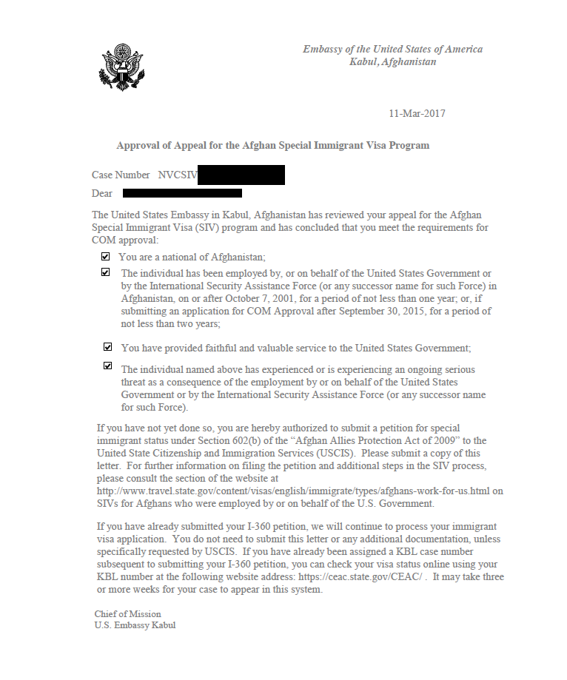
- If you do not have COM approval, see IRAP’s guides about applying for COM approval here.
- Note: There are Afghan applicants who are applying to the smaller SIV program limited to interpreters or translators. This is the Section 1059 SIV program. The 1059 program does not require COM approval. They begin the process by filing an I-360 with a letter from a general or flag officer.
- Received I-360 approval.
  - You will know that your I-360 has been approved because you will have received a notice of action (form I-797) that looks like this:
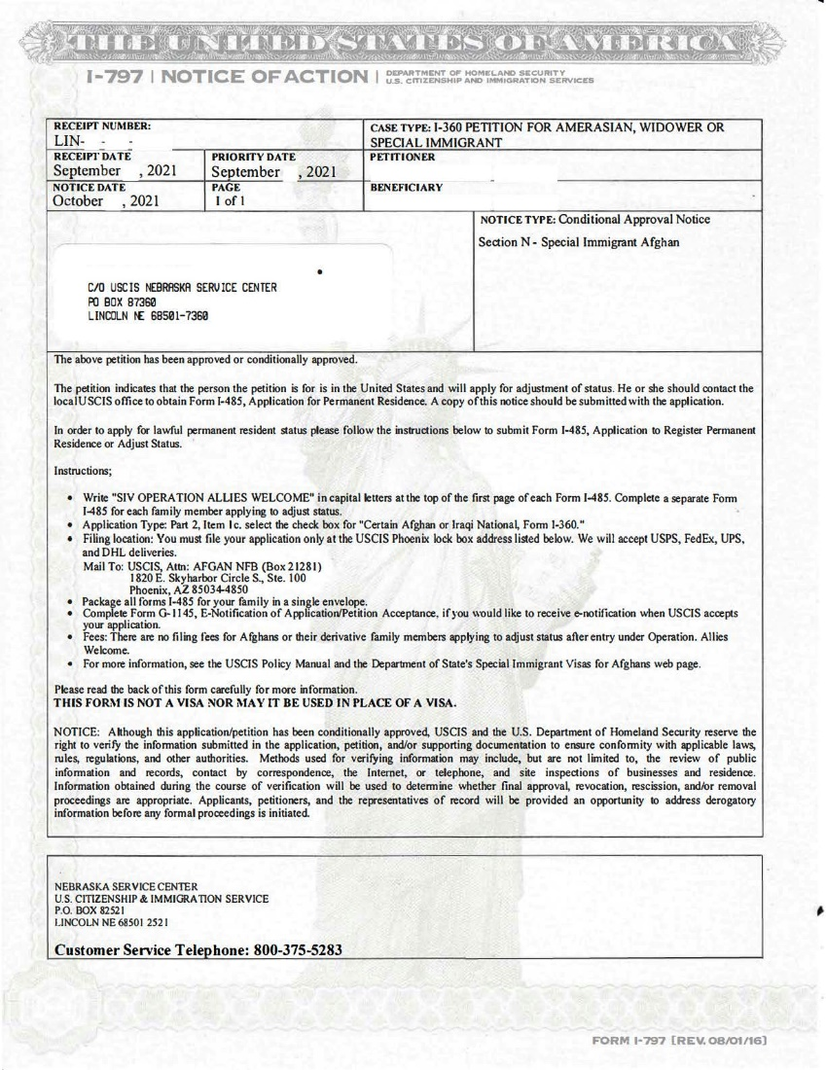
Your notice will be a “Conditional Approval” notice and say your petition is “approved or conditionally approved.”
If you have not yet applied for I-360 approval, please see IRAP’s guide on how to file an I-360 petition.

If I already was interviewed for an SIV, do I still have to file an I-485 adjustment of status?
If you entered the United States through parole and you are still in parole status, you will need a permanent immigration status. This is true regardless of the stage of your visa application when your evacuation occurred.

Application to Adjust Status - Form I-485
Once you have received form I-797 confirming that your I-360 petition has been approved, you can file the form I-485 with the U.S. Citizenship and Immigration Services (USCIS).
SIV applicants in the United States file the form I-485 to ask to receive lawful permanent resident status. This is also called green card status. Having permanent resident status or green card status means that you:
- Can stay in the United States.
- Can work in the United States.
- Can petition for certain family members to join you in the U.S. See IRAP’s guides about family reunification here.
- Eventually, to apply to become a U.S. citizen. To learn more about how to become a U.S. citizen, see the U.S. government’s guide to U.S. citizenship here.
Important things to know about filing the I-485 application
If you have an approved I-360 petition, you can file an I-485 application for:
- Yourself
- Your spouse who is with you in the United States
- Any unmarried children under 21 who are with you in the United States.
Each person must file their own I-485 application to receive lawful permanent resident status. You may mail all of your family’s I-485 applications together in one envelope, but you must include all of the required parts for each application.
If your spouse or any of your children under the age of 21 remain outside of the U.S., you must wait until your I-485 is approved to begin the process of applying for follow-to-join immigrant visas.

What to submit with each application
Each I-485 application you file for yourself or your family members should be accompanied by:
- A signed form I-485 with all relevant sections completed. You can review USCIS instructions on how to complete form I-485. Note that Afghan SIV applicants do not have to pay the filing fee.
- Two identical color photographs, sized 2x2 inches. For detailed instructions of what the photos should look like, read State Department’s passport photo guidance.
- A copy of the conditional approval notice Form I-797 of your I-360 special immigrant petition. You can see a sample I-360 conditional approval notice above.
- A copy of the “photograph” page of your Afghan passport, if available.
- A copy of your current Afghan tazkera or e-tazkera, if available, with translation into English and certificate of translation.
- A copy of the page of your passport with the parole stamp.
- A copy of your Form I-94. This is the document that you received when you entered the United States. If you do not have a copy of your I-94 you can search for your I-94 on CBP’s website. If you do not have a passport number or A number, you may be able to find your I-94 by entering your tazkera number.
- I-693, Report of Medical Examination and Vaccination Record, sealed, that has been completed by a “civil surgeon.” This a doctor who is certified to complete medical exams and I-693 forms. You can use USCIS’s Find a Doctor tool to find a doctor near you who is allowed to complete I-693 forms.
- For the application of your spouse, a copy of the marriage certificate, if available, with translation into English and certificate of translation.
- For the application of your child, a copy of a birth certificate, if available, or tazkera showing the father’s name, if available, with translation into English and certificate of translation.
What if I do not understand a question on the form or I am worried about how answering a question may affect my eligibility?
If you are not sure how to fill out part of the form or if you have a concern about your eligibility, you should speak to an immigration attorney. You can search for free or low cost immigration legal services providers in your area here.

Where to mail your application
All I-485 applications for Afghan SIVs should be mailed to the same address:
USCIS
Attn: AFGHAN NFB (Box 21281)
1820 E. Skyharbor Circle S
Suite 100
Phoenix, AZ 85034-4850

The application is free to file
You do not have to pay to file your I-485 application. Write “AFGHAN SIV OPERATION ALLIES WELCOME” on every page of your application. This will help the U.S. government know that your application do not require a fee.

Next Steps
You should receive a receipt notice called the Form I-797 from USCIS within a few weeks after submitting your I-485 application. If you submitted a Form G-1145 to receive automatic notification of the receipt of your application, you will receive it by email and by mail. If you did not submit form G-1145, you will only receive the receipt notice Form I-797 by mail.
The receipt notice means that USCIS has received your petition. USCIS has not decided your case yet. Some time later, you will receive a notice that your petition has been approved, denied, or if USCIS needs more evidence or an interview with you.

Interview
After you submit the I-485, USCIS may schedule you for an interview.

Change of Address
If you move and change your address, you can use the USCIS change of address website to update your address with USCIS.

Can I apply for SIV adjustment of status and asylum at the same time?
While it is legally possible to apply for both, you should talk with an immigration attorney about your specific situation.

How long does the SIV adjustment of status process take?
It is not possible to estimate how long this process will take. In the past, average processing times for similar adjustment of status applicants have been between 6-12 months.

What does the new SIV law mean for me? (31 July 2021)

Required period of employment The new law reduces the requirement for qualifying for the SIV program from two years to one year. You should submit a new application to COM if your case was denied because:
- You did not have enough qualifying work, or
- because you did not have proof of two years of work.
IRAP’s resources on submitting a new COM application may help you.
- IRAP's guide on contacting supervisors is here.
- IRAP's guide on the information that should be in your letters of recommendation and employment letters is here.
- IRAP's guide on finding contract information is here.

Spouses and children of people with eligible work who have died The new law helps families of people who were eligible for SIVs, but who have died. The spouse and unmarried children under the age of 21 of an SIV applicant who died can continue an existing application or submit a new SIV application. You will need to provide the same information and evidence about your spouse or parent's work as any SIV applicant would need to submit.
Instructions from the SIV program on how to apply are here in English. IRAP’s resources on submitting a new COM application may also help you.
- IRAP's guide on contacting supervisors is here.
- IRAP's guide on the information that should be in your letters of recommendation and employment letters is here.
- IRAP's guide on finding contract information is here.
People whose spouse or parent died must show that the spouse or parent completed at least one year of qualifying work.

One appeal per COM denial In some cases, a person receives a COM denial and files an appeal, and then their appeal is denied for a new reason. The new law says that, in this situation, you should be able to file a new appeal to address the new reason for denial.
If you have submitted a COM appeal, and your appeal is denied for a reason different than the one in your first COM denial, the law allows you to file a new appeal. IRAP's guide on filing an appeal is here. When you email the COM program, you should include this paragraph:
"I submitted a COM appeal and received a denial. I submitted an appeal. COM has denied my appeal, but has rejected my application for a new reason. The Afghan Allies protection Act, as amended by the Emergency Security Supplemental Appropriations Act of 2021 notes that I should receive one written appeal per denial. Because COM denied my application for a new reason, it must accept this appeal addressing the new reason for denial."

Removes some requirements for ISAF employment People who worked for ISAF with U.S. troops had to show that they worked as a linguist or in a role where they performed sensitive and trusted activities. This requirement was eliminated. Now a person must show employment of one year by ISAF or a successor mission.

Other changes to the SIV program The law also makes other changes that are important to the SIV program. The law:
- Provides money for emergency flights, processing, and housing for Afghan SIV applicants.
- Allows medical exams to be postponed so that SIVs can be issued more quickly.
- Gives 8,000 more visas to the Afghan SIV program.
- Repeats that the SIV program's requirement for processing within nine months includes all stages.
- Requires new reports from the U.S. government.

